**C.S.S**

**Corporate Scams and Solutions**

Dr Brindha Devi V [1], Hariharan M [2] , Srinivasan G [3] , Vihas S [4]

[1] HOD ,IT,Department ,Sri Sairam Institute of Technology

[2] [3] [4] Student, Sri Sairam Institute Of Technology

**Abstract:** In today's world corporate society plays a huge role and their scams are ruling throughout the entire globe. Corporate making most of their profits by using these scams .They are shielding their dark face and expressing their outer self as good one. The scams are performed with the base named Internet . So, this paper explains an alternate and efficient way of replacing Internet communication called **TERON** and establishing more efficient storage than cloud storage called **INFRYN.** This paper also explains the methods and ways to implement our idea in achieving a communication not similar to the internet but more efficient than **INTERNATIONAL NETWORK**. Also, we have mentioned the methods and possibilities to introduce a storage medium that is better than the optimized cloud data storage.This paper also explains how to create a storage medium(Infryn) efficiently where each and every users can store unlimited data easily and effectively.This storage medium(Infryn)stores each and every storage data with end to end encryption where no threat from hackers who cannot hack user's data.The difference between the cloud and INFRYN is that INFRYN storage medium stores the user’s data in their nearest location.

***Keywords: CORPORATE,SCAM,INTERNET,Communication***

**I.INTRODUCTION AND PROBLEM.**

Internet Communication has changed the entire world upside down. The Internet is everywhere and helps to access anything. But is that all in the Communication domain? What is the next advancement, and What is the need for an alternate technology? Do you know that the INTERNET can be provided for free to all? Yes. The Internet is a free communicating tool that establishes several types of sharing techniques and ensures the availability of collectives online. Corporate societies uses today's internet as a web to scam for making many profits. To break this web we are introducing our technology **HAK** which gives greater network than today's internet at a free of cost to each and every user at a very good speed advanced Internet connection speed. Of course, the Internet is a free resource we are paying only for the maintenance that is provided during the sharing of networks across the continent. There are many threats on the Internet such as virus attacks, phishing, hacking, security issues, privacy issues, etc. What if Internet communication is replaced with an idea that will resolve all the disadvantages of the Internet? The technique we come up with is an alternate communication platform called **TERON**.

**II.SCAM 2021**

In this paper we are going to explain all the scams done by the Corporates where they are running a secret society.GOOGLE INC, AMAZON INC one of most dream companies for the employers to work in these kind of environment.Similarly various other corporates here are earning Billions of dollars in each and every seconds. This would be the largest scam ever and let us go deeper into the scam. For example consider if we work in a company in any domain, with a desired job role, where these all comes under our institution (college) (ie) a student who has taken Engineering or any other stream is under control of his/her staff, the staff is under the control of The Principal, Chairman and so on.. Likewise Each and every people in our society is under the control of the Corporates who are ruling us. In a company, Except the share, stakeholders and CEO of the company no one knows the actual possibilities of the company's actual turnover. Imagine whether the common family man will be able to ask how the company is able to provide the salary for each and every one who are working here? Definitely Not, where the employee cannot even raise a single question. But we common people can raise the questions against the Corporates if we know the proper source of incomes. Well we all have a habit of taking more photos(selfies) in our Android phones and we have WhatsApp too where it requires more storage and backup for storing more files. Whatever it may be now a days we are not much interested in using laptop and computers so we completely moved to Smartphones where we don't have much storage to create backup. So we moved to **CLOUD STORAGE**.

**GOOGLE.**

Google was initially a client who gives the content that the user looks for once the people started using Google for even a simple search . Google has segregated the types of data in seo as mail /message based video / audio content . General info and others slowly in the free gateway called the Internet , Google has acquired the seat of assistant ,then officer and new a corporate . How do Google and other corporates earn? Before going into it I would like to say. The categories search for video, made YouTube for mail it became Gmail and so on .As of today we use virtual classroom and virtual marksheet. How could I mean this is as a scam? What is the connectivity to the intro of this paper and Google growth? well , technology and basic innocence of human brain has made to us work as invisible slaves, actually schools, colleges , industries, IT , theatre ,public property ,telecom, grocery, and many more the state the country everything is under these corporate. Mainly the Agriculture .The architecture will explain the rule and control of corporate in every manner starting from a student to the biggest corporate. Google has 'n' number of cloud storage servers and most of the people are today having more than one Google account. How many of us has noticed that the price of smartphones is literally higher than the PC's and Laptops even though we have more storage capacity in Laptop?. But we would go for smart phones, which is compact and handy this is the main disadvantage we face for buying an electonic device like laptop so this point is one and only advantage for corporates.

**ANDROID:**

In the level of balance Google bought android for a huge amount and started to upgrade the various level of APK and Android versions such as Alpha 6.0 version such as Beta 1.1(2010s version) ->candy (1.2)v 2012 2.0 upgraded -> doughnut 2012 version Eclair 2.2v 2012-13 freyo 3.0(2013v) -> honey comb 3.2v(2013 to 14) ->ice-cream sandwich (4.2.1 v) ->jellybean ->kitkat ->lollypop (5.0v)2015->marshmallow(6 .2V)Naugut(6.2v),Oreo(2018),Pie (2018),Q or 10.0 version till date(2019).There are versions of android till date. If we are buying an android phone . The hardware components rate would be actually some 10% to 12%. The real rate would be 88 to 90% only for software's and operating system. Moreover we will be paying for the android version that is yet to be launched . If we are buying (5.0) lollipop version for 11000 inr. The inr value will be having the excess amount for upcoming android OS version to our cloud storage medium is a virtual platform according to our vision. But really they are their sheets of glass and glass servers.

**III.AN OVERVIEW OF CORPORATE SCAMS.**

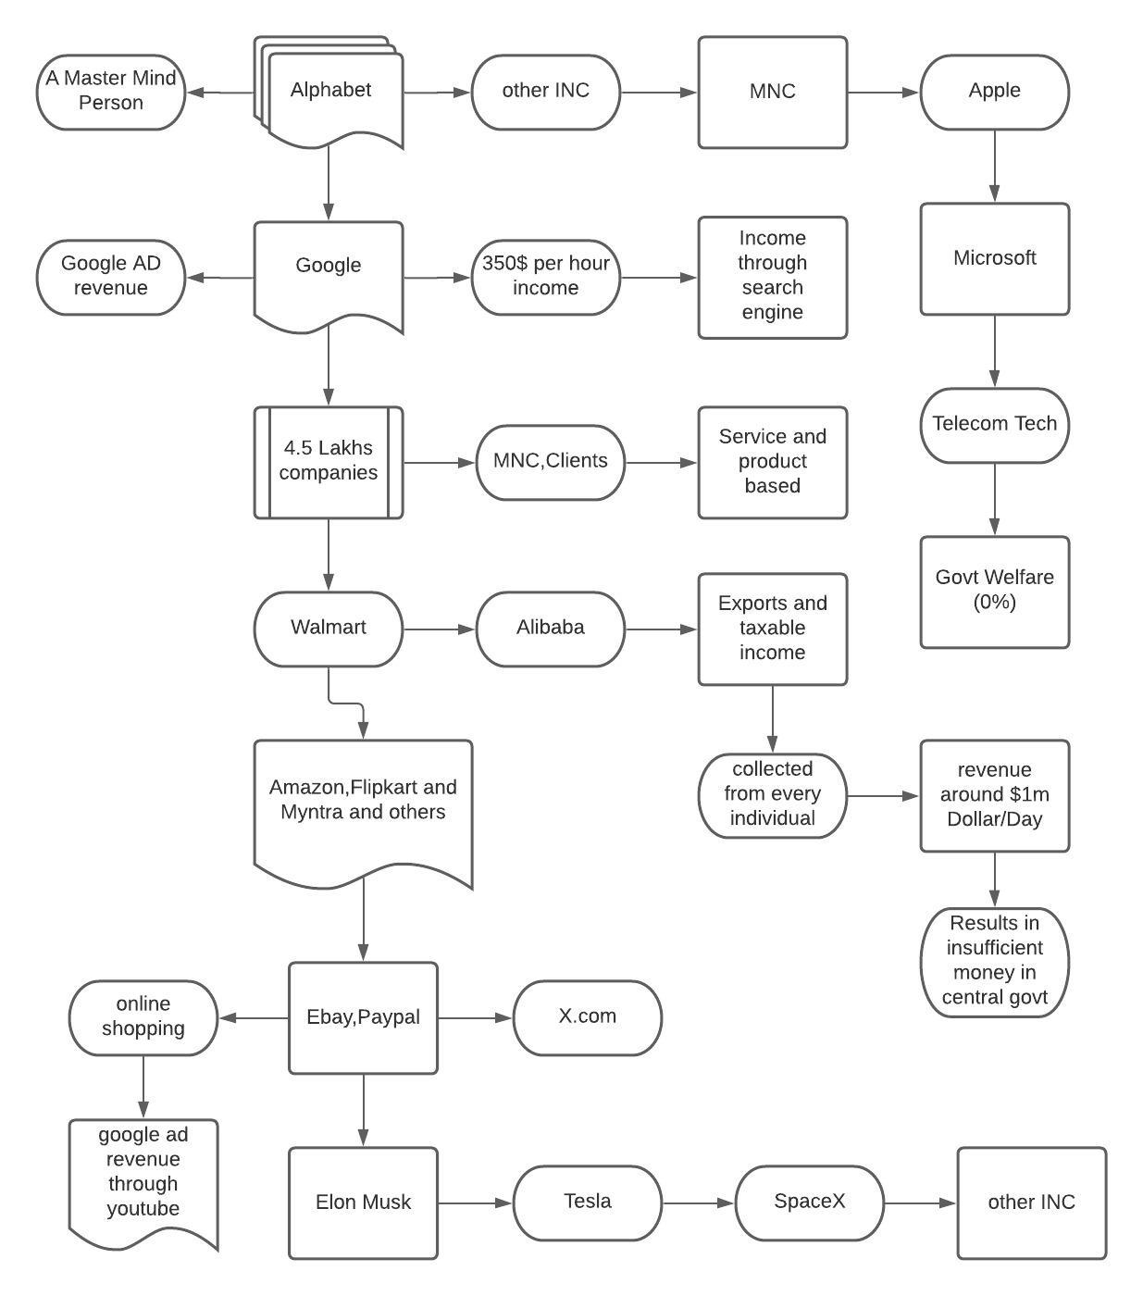

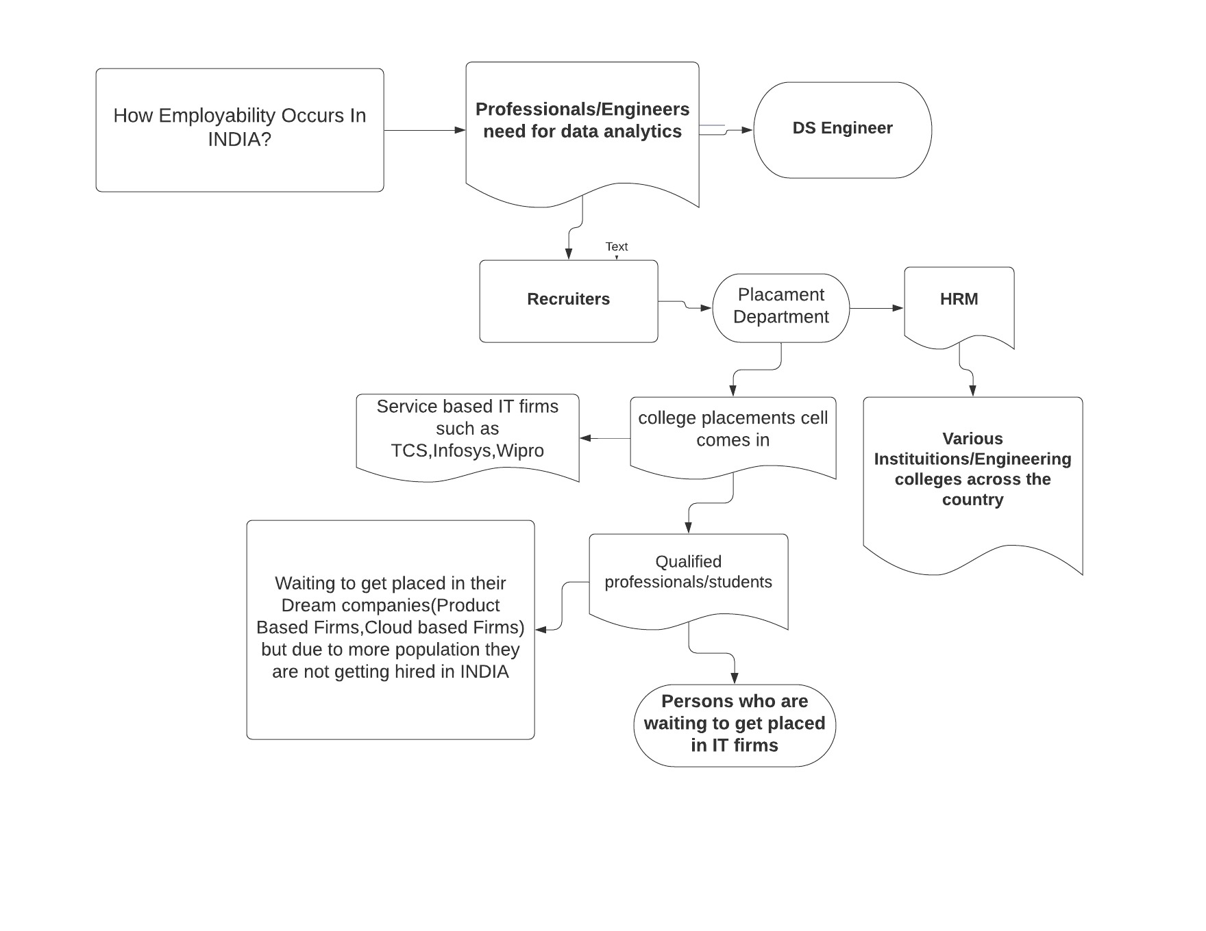

**DESCRIPTIVE RESULTS:**

So imagine, if one corporate Google earns this much then just imagine how all other services earn. So what about Amazon, Netflix and others. You all might think that there is no connection in between, but go through the architecture once again. We can find every company, domains in relation with Google and Alphabet. Yes, we have been fooled these many years there is the sample algorithm for how Google photos earns with data.

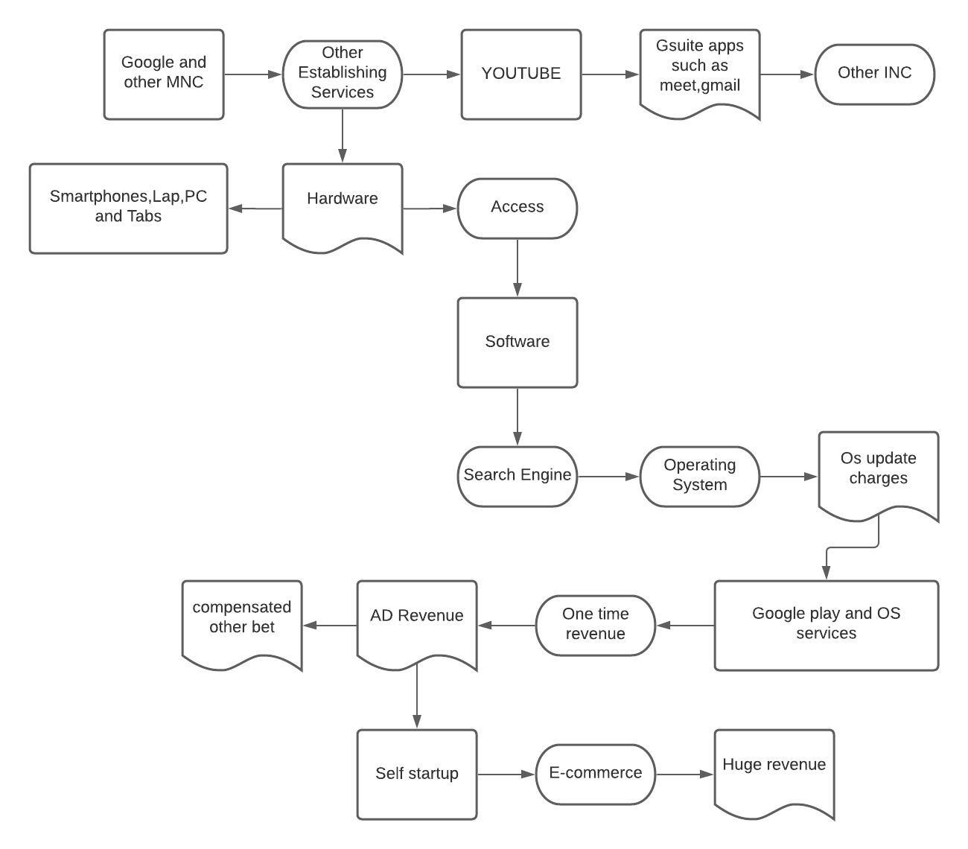

The above architecture represents the data monetization of these corporates.

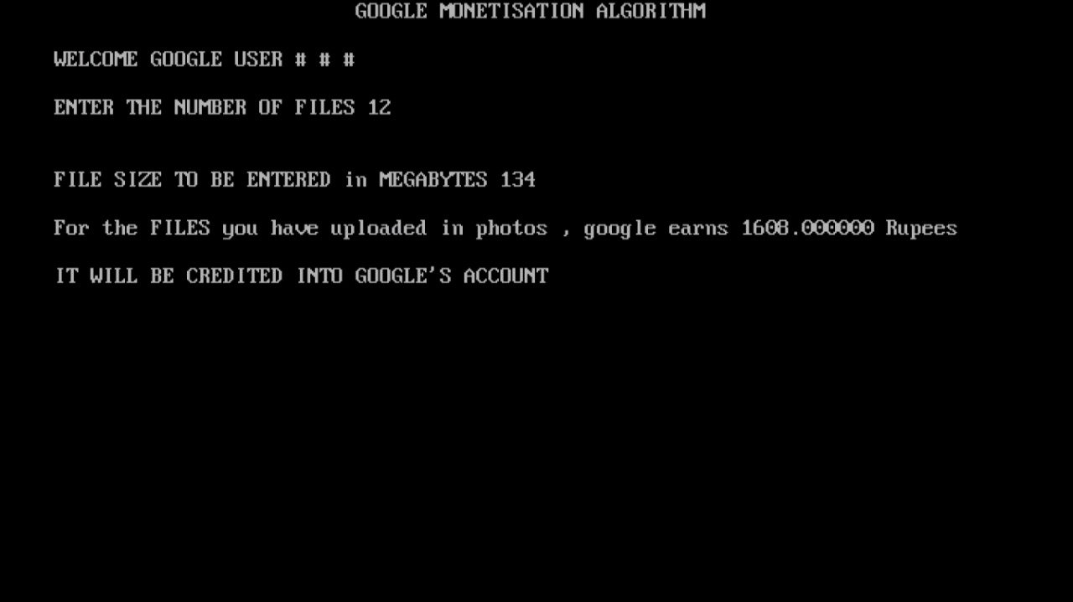

The sample algorithm of Google Cloud may look simple and easy. But this simple algorithm earns a lot. Let us see some more algorithm examples.

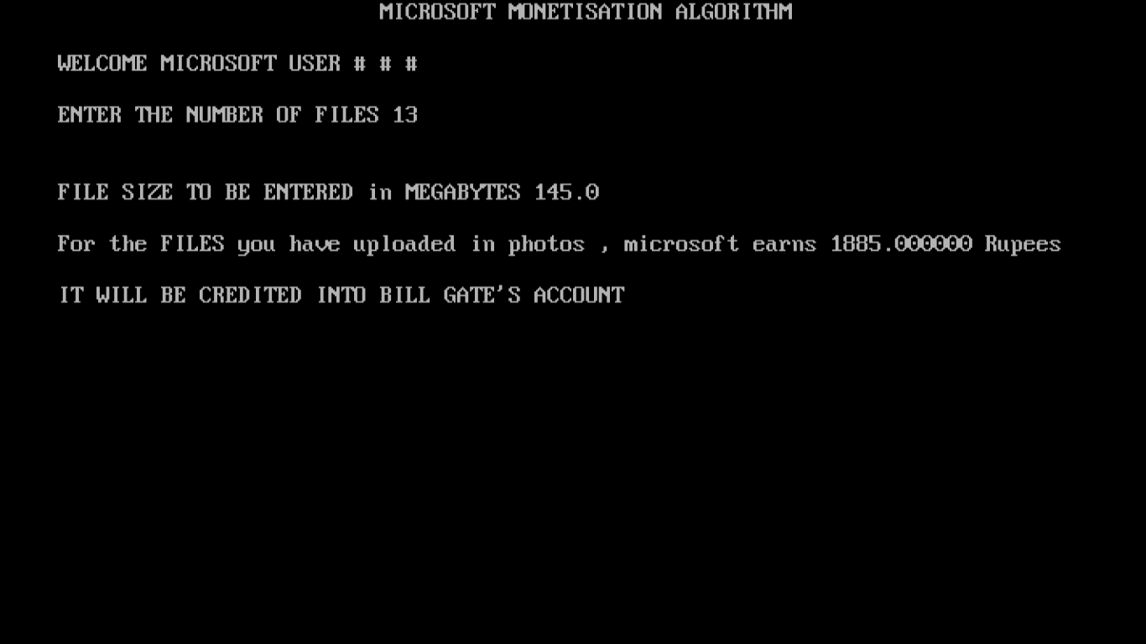

Similarly,we have designed a simple algorithm for Microsoft earnings.

**SOLUTION:**

So we can clearly understand that we are just fooled by those corporates. And, Internet, we are paying for the broadband connection we use. Actually internet is free communication channel in which these corporates rely. So how to over come this corporate scam? It is highly impossible to eliminate these corporates with head to head dash. So if we eliminate the main source of the corporate link the internet we can destroy the scam completely, if we can replace the overall Internet Communication. We could eliminate the scam .

**1.TERON:**

TERON will be the alternating communicating platform for the Internet where we can optimize the search engines and the necessary information and details regarding the information we want.

TERON will be the only communication tool where we could browse whatever we want without the internet. Without Internet sharing and establishing a connection may sound weird, but that’s what the idea is based on. TERON uses DASH7 technology to stay connected within the radius specified. So, once we are connected to the local network, the connection will be established without the Internet. Well, developed and upgraded ideas could make it still stronger and establish faster and constant connectivity by TRANX.

**2.DASH7**

DASH7 (D7A) is an **Open-Source Wireless Sensor and Actuator Network Protocol**, which operates in the range of ***433 MHz***, ***868 MHz***, and ***915 MHz*** unlicensed ISM band

In this idea, we are using DASH7 technology which enables the user to communicate with the radius which can be characterized based upon the location of the server. [1]

But this technique uses several EMR(Electromagnetic Radiation which is surrounded in the forms such as waves,microwaves,X-rays and gamma rays)which is not the desired goal. We need to eliminate the use of EMR so we use another technique called **TRANX.**[2]

**3.TRANX**

**TRANX** is our own communication technique using light where we can transfer information(file, message, video, audio). We can implement a data transfer technique using light for each specified location which will be purely wireless.

We can receive and send i.e communicate using visible light, infrared. The light can travel through these light emitters. In this technique, there will be no ElectroMagnetic Radiation that affects human health, birds, and the whole environment.

There is **no limitation** for file sharing which allows the bulk transfer of information. If this process is implemented, then the usage of sim cards will be reduced which prevents radiation from affecting humans and resulting in minimizing the number of broadband providers.

The users will be using **LISO**(Light Selection and Optimization) instead of **Sim Cards**. users will be creating their own identity and cannot be accessed by anyone which also proves that our technique gives good protection and privacy. LISO will replace Sim cards.

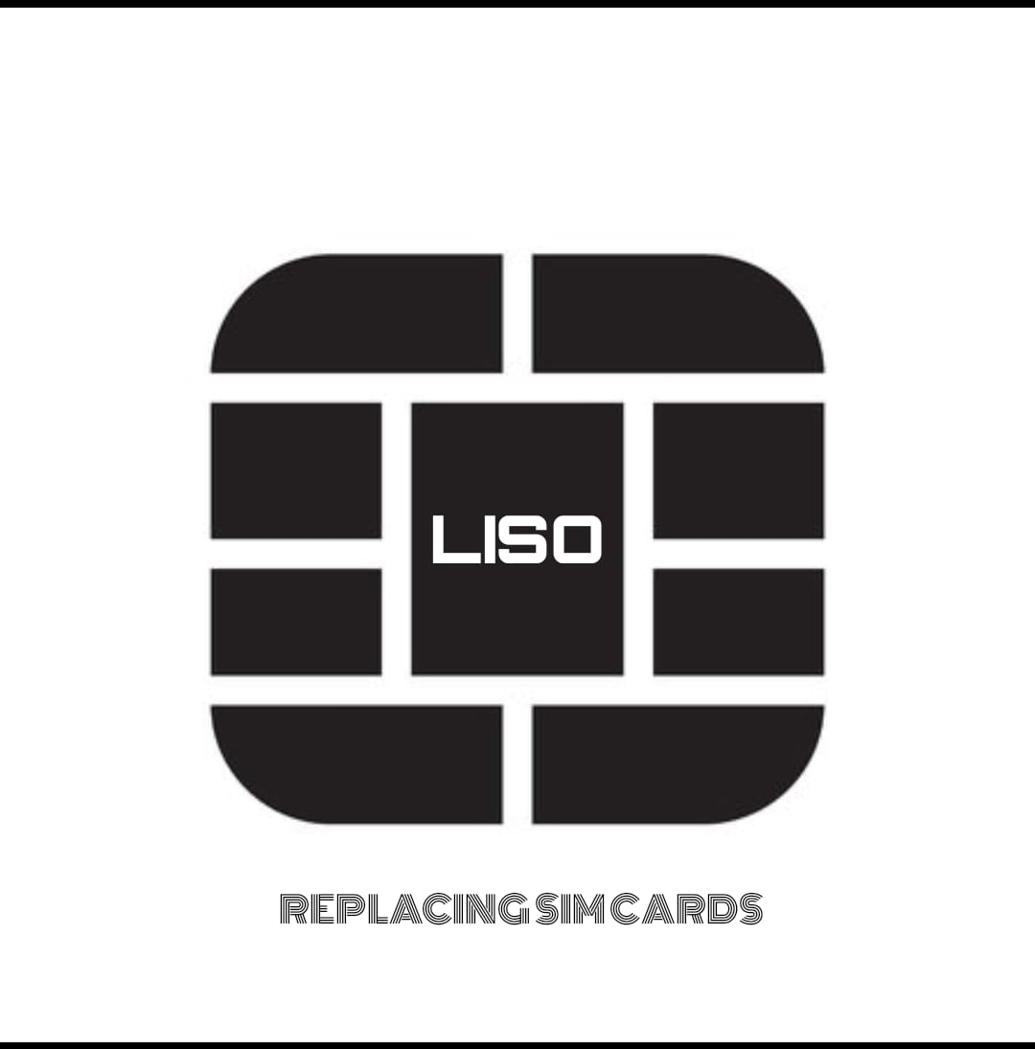

FIGURE 1

The unique **LISO ID** which is so-called as the phone number in SIM cards can be changed. i.e, The user’s phone number is not fixed and it can be changed depending on the interests.

This method allows users to create their own unique identification number. This makes the user's number encrypt their own block. The special feature of this technique is that the user's information is stored in the block as a back up until doomsday.

**IV.WHY TERON?**

There are many threats on the Internet such as virus attacks, phishing, hacking, security issues, privacy issues, etc. In TERON there will be no such threats or limitations. Blockchain techniques have been introduced in TERON communicating technique.

In TRANX we will give our utmost priority to our user's safety. So, we have used blockchain technology to prevent phishing, threats from various hackers.

If a hacker tries to steal or access a user's data in TRANX, the hacker's system will be automatically corrupted because each and every user's data are encrypted in each and every block, so the system automatically identifies the person and terminates the entire block where the hacker tries to steal it.

A basic overview of implementation is represented in the pictorial form in figure 1.

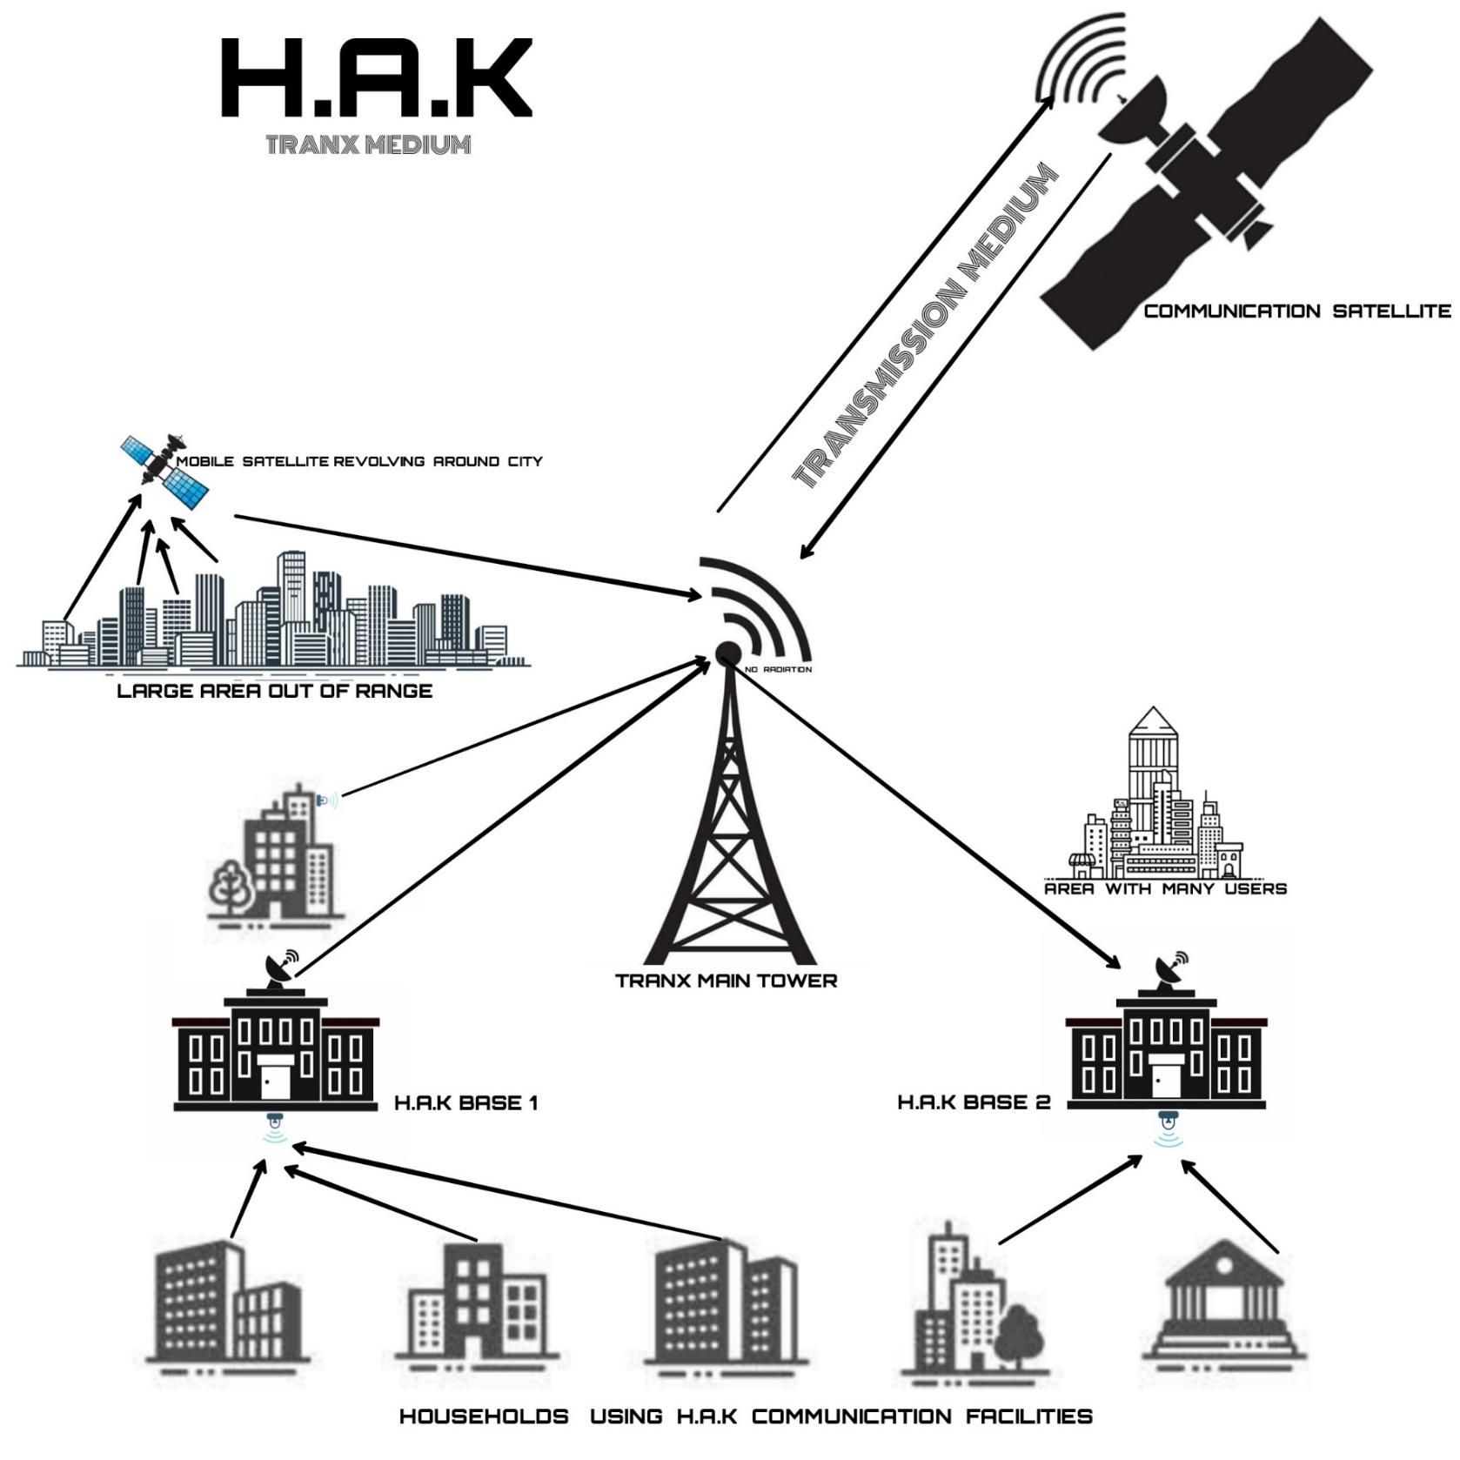

FIGURE 2

**V.1.IMPLEMENTATIONS TO CREATE OWN BLOCKCHAIN**

Let’s see the main steps users need to follow to build a blockchain.

Step 1. Knowing the use-case.

If the user’s business interests lay in the smart contracts area, data authentication and verification, or in smart asset management, defining their objectives clearly at the beginning is very important

Step 2. Choosing a consensus mechanism.

For the user’s blockchain to operate smoothly the participating nodes must agree on which transactions should be considered legitimate and added to the block.

Step 3. Picking up a blockchain platform.

The user’s choice of blockchain will depend on the consensus mechanism they've selected.

Example of popular blockchain platforms:

• Ethereum (market share — 82.70%)

• Waves (WAVES)

• NEM

• Nxt (NXT)

• BlockStarter

• EOS

• BitShares 2.0

• CoinList

• Hyperledger Fabric

• IBM blockchain

• MultiChain

• HydraChain

• BigChainDB

• Openchain

• Chain Core

• Quorum

• IOTA

• KICKICO

Step 4. Designing the Nodes

We can consider blockchain as a wall. Then nodes are meant to be considered as the bricks. Node is a device connected to the internet. It plays a major role in the blockchain. It performs major tasks such as storing data, verifying, and processing the data. Nodes provide efficiency, support, and security to the Blockchain.

There are many choices you have to make about the nodes that you employ:

1. What are they going to be in terms of permissions: private, public, or hybrid?

2. Will they be hosted on the cloud, on-premise, or both?

3. Select and acquire necessary hardware details, such as processors, memory, disk size, etc.

4. Pick a base operating system (most common choices would be Ubuntu, Windows, Red Hat, Debian, CentOS, or Fedora)

Step 5. Establishing the blockchain’s internal architecture

The required parameters have to be chosen very carefully as this couldn’t be changed once the blockchain starts running. It will be a really good idea to take the user’s time and think through the following:

• Permissions (defines who can access the data, perform the required transactions and validate them)

• Address formats (decides how the addresses of the blockchain would look like)

• Key management (this part develops a system for storing and protecting the private keys which store the blockchain access

• Key formats (decides key format which generates signatures of the transactions)

• Native assets (to define rules to the native currency issued in the blockchain)

• Asset issuance (this part establishes the rules for creating and listing the assets units)

• Asset re-issuance (this part establishes the rules to create more units of the open assets)

• Multi signatures (this part defines the keys required to validate a transaction.)

• Parameters (to estimate maximum block size, rewards for block mining, transaction limits)

• Native assets (to define the rules of a native currency)

• Block signatures (to define the way blockchain participants are required to create blocks and to sign them )

• Hand-shaking (to establish rules of how the nodes will identify themselves while an active connection)

• Atomic swaps (plans for the contracts which enables the exchange of data without a third party)

Step 6. Taking care of APIs

Making sure whether the chosen blockchain platform provides pre-built APIs.If they are not, there are several reliable blockchain API providers. Some of them are:

• ChromaWay

• Bitcore

• Neuroware

• Tierion

• Gem

• Coinbase’s API

• Colored Coin APIs

• Blockchain APIs

• Factom Alpha API

Step 7: Design the Interface (Admin and User)

A well-thought-out interface ensures smooth communication between the blockchain and its users.

The factors that should be considered at this place:

• Web, mail, and FTP servers

• External databases

• The front end and programming languages (e.g. HTML5, CSS, PHP, C#, Java, Javascript, Python, Ruby).

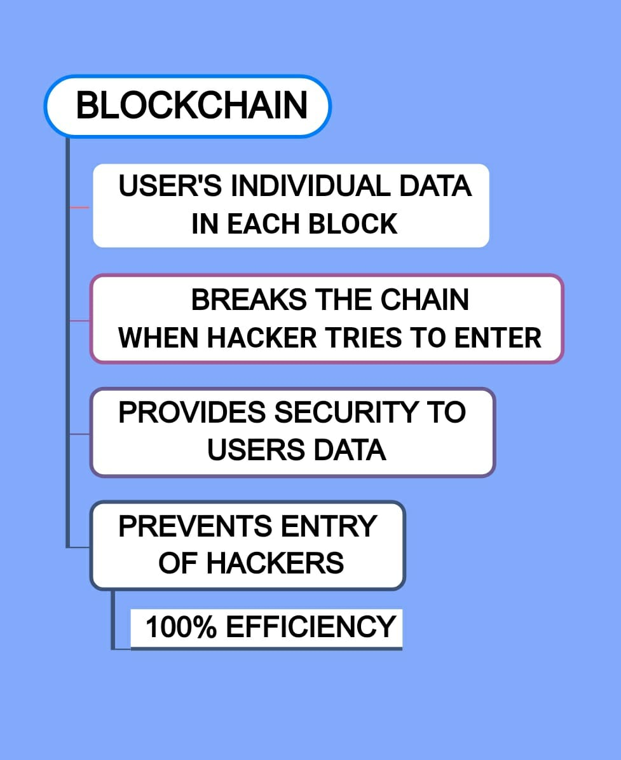

**2.INFRYN (BEYOND CLOUD)**

Each and every user can access their data easily and efficiently. The difference between the cloud and INFRYN is that our storage medium stores the user’s data in their nearest location. It can store n amount of data, to be precise each and every individual block which allows them to store unlimited pieces of information. They can access their data with their unique identity(account for INFRYN)

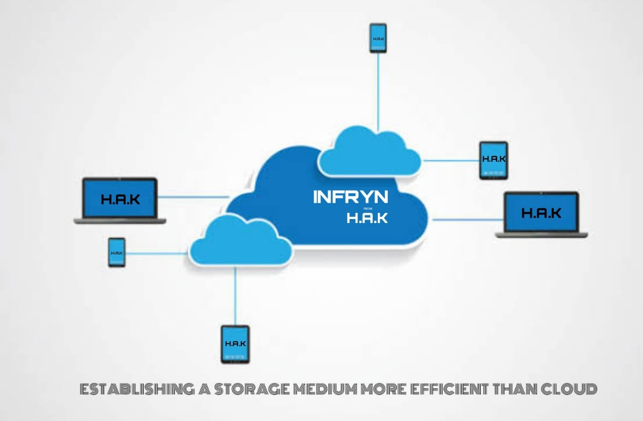

FIGURE 3

.

**3.IMPLEMENTATIONS TRANX**

For each distinct location (centralized) there will be a centralized tower where users can send and receive data(file sharing, video, audio) through light with the help of light eminent devices (for every k.m).

Conventional mobile communication towers will be replaced. This model will be more effective in preventing network disruption during natural calamities. And TRANX totally removes the **Biological issues** which are caused by EMR which is the most important feature in this whole topic and it was the main reason for us to come up with this idea.

This technique works efficiently for sending and receiving the data between the users in a fraction of seconds as the light is used as the medium. Consider a case where there is a disruption or power failure in the tower, then there is a prebuilt solution that provides an alternative method. **Mini-towers** or the more effective **drones** will be installed for every **50 K.M** which will be recharged by solar energy.

**4.IMPLEMENTATION OF STORAGE MEDIUM INFRYN**

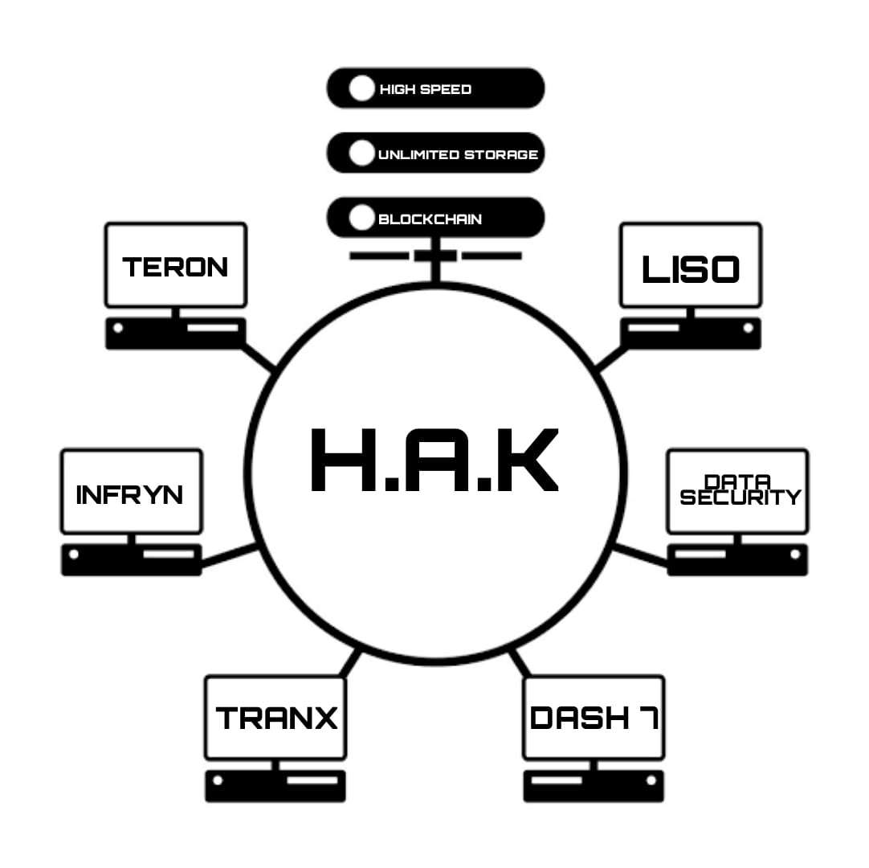

FIGURE 4

Users can build their own storage instances by using virtualization software like **Oracle VirtualBox.** Users can create multiple instances of different types on your Virtual box. Each instance will have its own IP Address. Now, the user can use networking to join these different instances. Users have to remember that if they want to scale it further, they would need high spec end machines. In different circumstances, users can also use services like Linode and Digital Ocean to buy storage instances and Networking capabilities on rent to connect with servers. If the Figure 3

users want to create their own storage system, then they will need to buy a server from companies like **Openstack**. As a consequence, perfect encryption is put and uploaded as content. Each instance will have its own **TERON** (instead of IP) address. Here users can upgrade with **TRANX** (optical wireless communication), if they want to develop further they will need some high specs like Linode and a digital version for storage and communication capabilities. This software would be bought for rent on a large scale.

Public storage is probably more preferable (their security will likely be better and there’s less maintenance on your end).

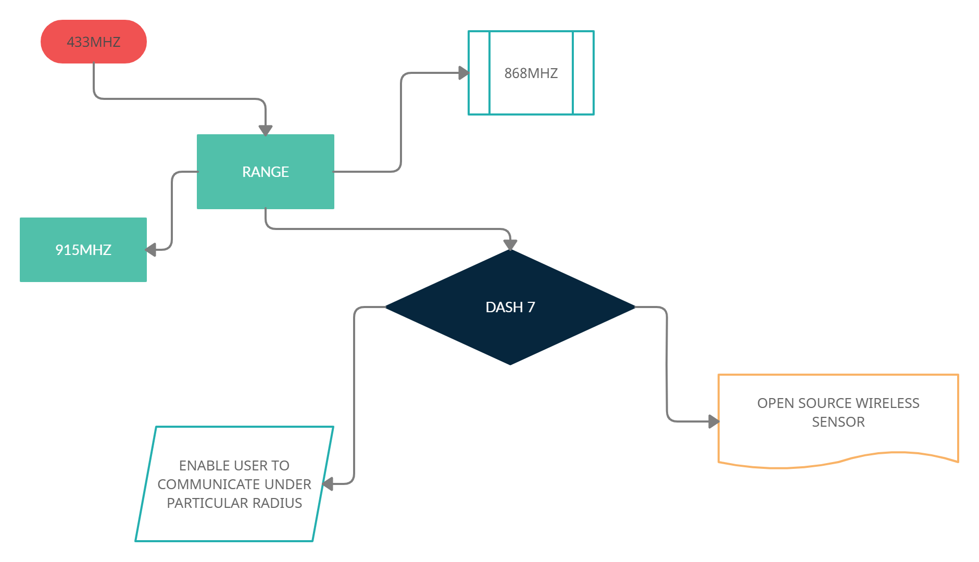

***(ARCHITECTURE OF DASH 7)***

DASH7 is an open source Wireless Sensor and Actuator Network protocol, which operates in these frequencies of 433 MHz, 868 MHz and 915 MHz . DASH7 provides efficient battery life. It can range up to 10km radius for the accessibility of the information, low latency for connecting with the users.It also has a very small open source protocol stack, AES 128-bit shared key encryption support, and data transfer of up to 167 kbit/s. The DASH7 Alliance Protocol is the name of the technology given by the non-profit consortium called the DASH7 Alliance.

DASH7's allows information signals to penetrate into the walls, windows, doors, and other substances quite easily making it more efficient that acts as obstacles.This allows user to communicate very easily with ease and faster at rate.

DASH7 can be used benefited from the open source library called OpenTag, which provides developers with a "C"-based environment in which to develop DASH7 applications quickly and easily. So in addition to DASH7 (ISO 18000-7) being an open source, ISO standard, OpenTag is an open source stack that is quite unique relative to other wireless sensor networking like Zigbee.

DASH7 networks serves applications in which low power usage is essential, and data transmission is typically much slower. DASH7's main method of communication is by command-response, which by design requires no periodic network "hand-shaking" or synchronization between devices. Implementation of the DASH7 Alliance protocol should focus on completeness, correctness and being easy to understand. Performance and code size are less important aspects for clarity a clear separation between the ISO layers is maintained in the code.A DASH7 system of devices is inherently mobile or transitional. Unlike other wireless technologies DASH7 is upload-centric that is it has more upload speed, and has less download-centric(speed).

DASH7 provides a link budget of up to 140 dB with 27 dBm transmission power, which positions the technology as Medium Range, compared to Short Range.For example Bluetooth and WiFi.

DASH7-based TPMS will provide end users with more accurate tire pressure readings, resulting in greater fuel economy, reduced tire wear and tear, and greater safety. DASH7 products are also being designed and used for other automotive applications like supply chain visibility.DASH7 defines two types of frames: a foreground frame and a background frame. The foreground frames are regular messages which contain data or data requests. Background frames on the other hand are very short broadcast messages.

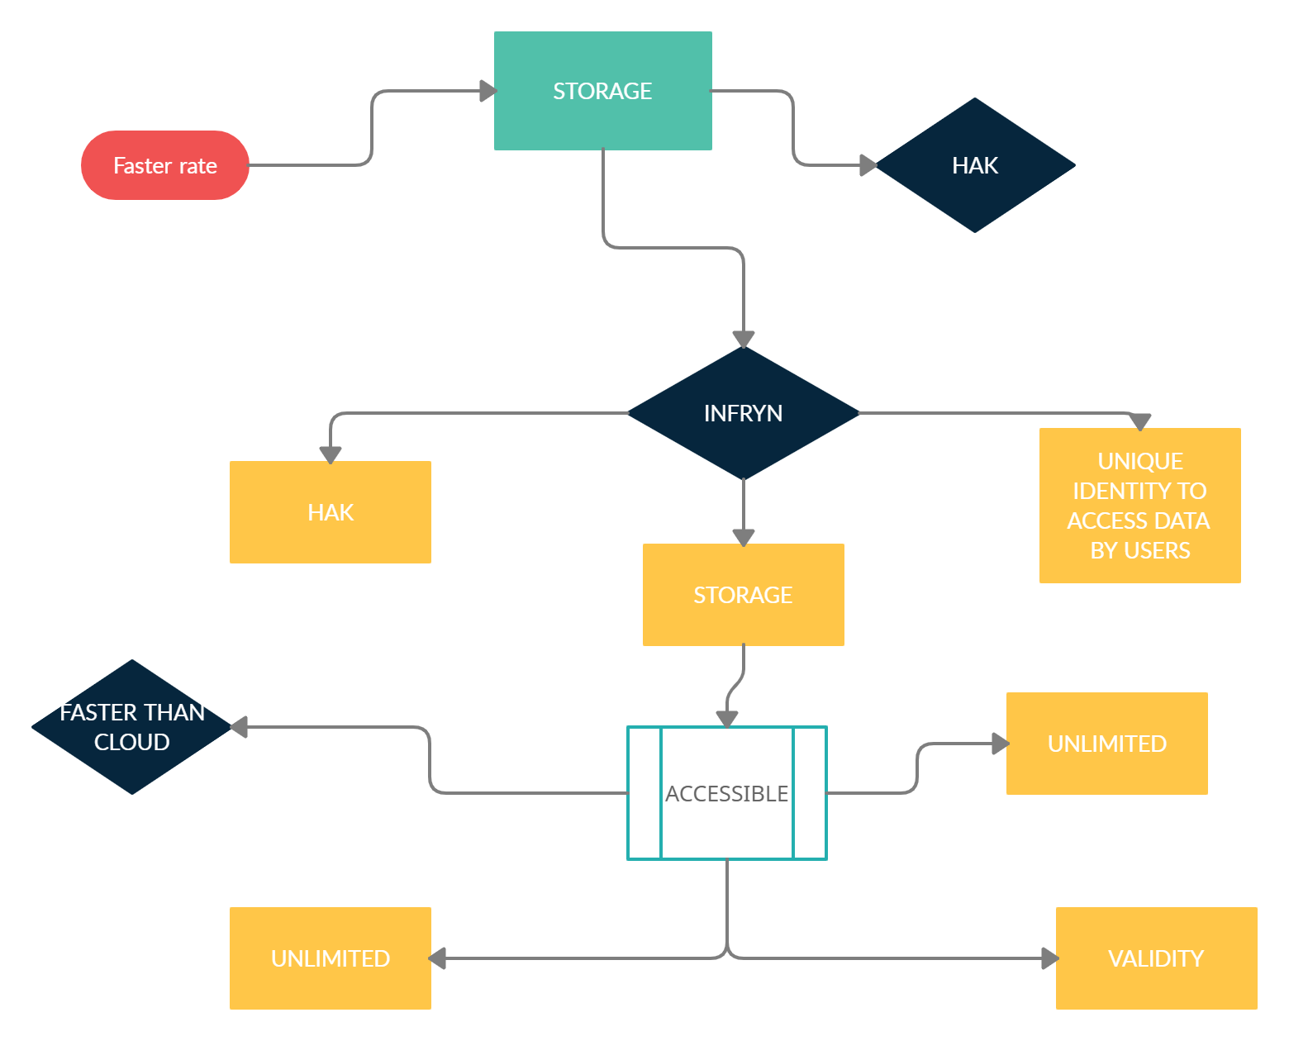

***(ARCHITECTURE OF INFRYN TECH)***

How can we encrypt users' data in INFRYN?

We can use a key derivation function to convert the user's password into an encryption key. We can use the derived key to encrypt the generated key. The resulting ciphertext of the data encryption key could then be stored safely in the user table of the database.The key that actually encrypts the data is only decrypted long enough to decrypt the data that it encrypted. You'll need to store that key in the session in order to avoid the need to ask the user for his password on each decryption occurrence.We can store the key encryption key on a Key Management Service such as INFRYN. We can generate a random key, using a CSPRNGm, and use this random key to encrypt the user's data. We can create a new, different random key for each user. This is called the DEK, or data-encryption-key.

We can take the user's password and run it through a PBKDF using a reasonably high work factor or number of iterations and a random salt to create a second key, the key-encryption-key. then we can encrypt the DEK(Data encryption key) using the KEK, and store the encrypted DEK and the salt in the database.PBKDF - Password based key derivation function (PBKDF) makes it harder for someone to determine your Master Password by making repeated guesses in a brute force attack.PBKDF prevents password cracking tools from making optimal use of graphics processing units (GPUs), thus reducing guess rates from hundreds of thousands of guesses per second.

The process of storing the data in INFRYN would be way faster than the current technologies. Because of its light-speed travel and its factor of storing in its near location.

INFRYN allows its users to access and modify the data content in the storage devices by authorizing User’s unique identity.The data stored with

INFRYN technology would have many benefits over current cloud technology.INFRYN would be faster than the cloud technologies.INFRYN would let its users to store unlimited data at a very low cost contrary to the current cloud technology.

The data stored with the INFRYN technology would be valid for a very long time. This INFRYN has the capability to replace all the storage devices such as CDs, pen drives, hard disks, SSD, and even pay as you go cloud.

PBKDF prevents password cracking tools from making optimal use of graphics processing units (GPUs), thus reducing guess rates from hundreds of thousands of guesses per second. It has an interesting property when using HMAC(Hash message authentication code) as it uses pseudo-random function. It is possible to trivially construct many numbers of different password pairs collisions within each pair.1 Password accounts use PBKDF2-HMAC-SHA256 for key derivation. All accounts are created using 100,000 iterations.1 password accounts provide a place for users to store various passwords, software licenses, and other sensitive information in a virtual vault that is locked with a PBKDF.

DASH7 can be used benefited from the open source library called OpenTag, which provides developers with a "C"-based environment in which to develop DASH7 applications quickly and easily. So in addition to DASH7 (ISO 18000-7) being an open source, ISO standard, OpenTag is an open source stack that is quite unique relative to other wireless sensor networking like Zigbee

**Syncthing** is a continuous file synchronization program. It synchronizes files between the computers in real-time. It safely protects the data from prying eyes. User’s data is their own data alone and they are the only deserved ones to choose where it can be stored, whether it would be shared with some third party, or the way how it's transmitted over the internet.

Syncthing is an open-source, cross-platform personal storage solution. All that the user needs is the devices from which they want to share data across, may it be from the servers, from the desktops, or even the mobile devices.

So, once the syncthing software is installed and set up is done, the devices will be synced and stay synced as long as the devices are online.

There will be completely no mess around IP addresses and firewall holes. User’s data never leaves their machines without their concern. The data which would be transferred between devices will be in an encrypted form.

**Syncthing is:**

Private: None of the user’s data is ever stored anywhere else than their computers. There would be nothing like a central server that might be compromised, legally, or illegally.

Encrypted: All communication is secured using TLS. The encryption which is used includes perfect forward secrecy to prevent any eavesdropper from never gaining access to the user’s data.

Authenticated: Every node will be identified with a powerful cryptographic certificate. Only the nodes which the users have explicitly allowed can connect to their cluster.

Open Protocol: The protocol will be a documented specification — and there would be no hidden magic behind the screens.

Open Source: All source code will be accessible on GitHub

Open Development: Any bugs found immediately will be turned visible for anyone to browse, with no hidden flaws.

Open Discourse: Development and usage will be always open for conversation.

**Easy to Use**

Powerful: Users can synchronize as many folders as they need with different people or just between their own devices.

Portable: Configure and monitor Syncthing via a responsive and powerful interface accessible via the user’s browser.

Works on Windows, FreeBSD, Mac OS X, Linux, OpenBSD, and Solaris. Users can run it on their desktop computers and could synchronize them with their server for backup.

Simple: Synching doesn't need any IP addresses or any type of advanced configuration: it just works, over LAN and over the Internet. Every machine will be identified by its ID. Users can give their ID to their friends, and share a folder, and watch: UPnP will do if the user doesn't want to port forward or the user doesn't know how to do it.

**Problem with Electromagnetic Radiation:**

According to many scientists, EMFs could affect the human body’s nervous system function and has a chance to cause damage to cells. Cancer and unusual growths may be one symptom of very high EMF exposure. Some other symptoms may include:

* Headache
* sleep disturbances, including insomnia[3]
* depression and depressive symptoms
* tiredness and fatigue
* dysesthesia(a painful, often itchy sensation)
* lack of concentration
* changes in memory
* dizziness
* irritability
* loss of appetite and weight loss
* restlessness and anxiety
* nausea
* skin burning and tingling
* changes in an  electroencephalogram (which measures electrical activity in the brain)[4]

In a long and careful experiment, German scientists found that migrating robins became disoriented when exposed to electromagnetic fields at levels far lower than the safety threshold for humans.[5]

“Cell phones and towers emit a low frequency of 900 or 1800 MHz, called Microwaves.Studies have found that they can damage thin skulls of chicks and thin eggshells” says a researcher from SACON.[6]

The team at the Centre for Environment and Vocational Studies Of Punjab University, headed by RK Kohl, exposed 50 eggs to EMR for a duration of 5 minutes to 30 minutes.” All the 50 embryos were damaged.” says Kohli.

“Birds are known to be Highly sensitive to magnetic radiation. Microwaves can interfere with their natural sensors and misguide them while navigating and preying” says Daniels

**MERITS:**

Speed – The speed of communication among the users will be high. This enables the transfer of information (data) at light speed

Security – The data of the users will be free from hackers attack

Storage – This is permanent storage which will be available for life long

Eco-friendly- EMR radiation is prevented by our TRANX which will create good eco friendly

Cost efficiency – TERON gives a good cost efficiency to the users when compared to broadband internet

This makes every class of people’s use more effective.

The storage elements of the user are maintained by themselves and it is stored at a very close interval of distance when compared to the cloud storage.

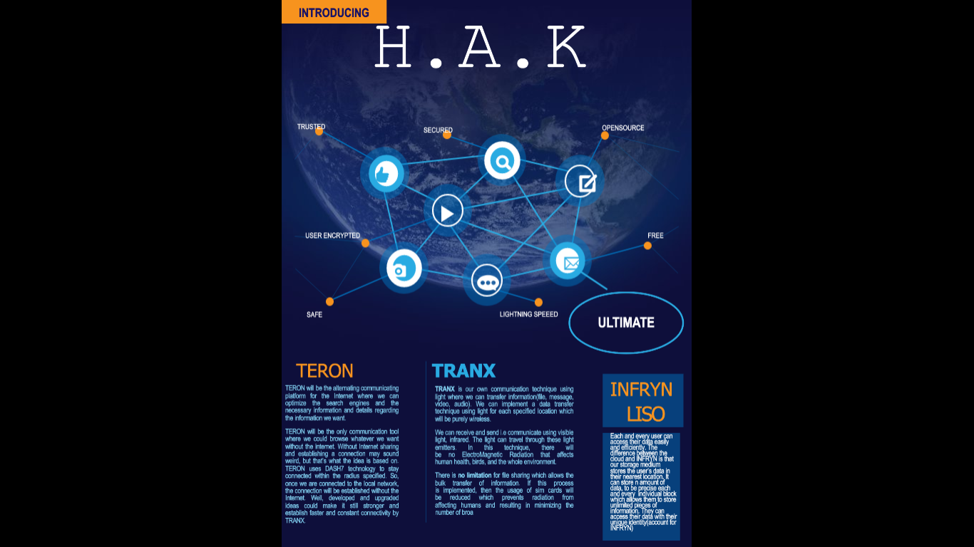

**IMPACT:**

We know how the internet is essential in our day to day life

TRANX is an alternative to the Internet at a very much lower rate which encourages changes in our world.This will be a big industrial revolution in telecom resources thus making a big impact on our INDIAN economy by producing a great number of direct and indirect job opportunities for the people from various sects of the society. By adopting INFRYN, we could store a humongous amount of data in a more comfortable and socially transparent way.This INFRYN will replace all the storage devices such as CDs, pen drives, hard disks, SSD, and even limited cloud.The data of the users is available till doomsday. This storage held by employing this technique cannot be hacked and has a good security feature that will enable the users to handle their storage on their ownUsers will be owning the rights and authority of their own storage of data and not even the service providers will have the batch file.By using TERON, we can rule out the multiple network services in our country, and the whole nation will use this communication technique i.e a single communication network will play a big role after implementation.This is not only for mobile communication but also can be used for communication of satellite.There will be no disruption in signal and loss during transmission with this technique.This idea is not only concerned about modern technology but the whole ecosystem, a shift in society, and for our India’s future.

**VI.Conclusion**

We strongly believe that this idea can not only be commercially revolutionary but can change the lives of common people.

We aim to provide the most complex and useful platforms to the people of the society free of cost or at very low cost.

To put it in other words, we tend to change and enhance the whole current communication system, storage system, and its related domains.

We strongly believe that if this idea reaches wide positive responses and support from some right people, then this would give a boost to our economy directly and indirectly and obviously would be a history-making(changing) concept.

Technology is all about updates. So, we believe that our idea will receive positive responses.

Let’s make India proud and create a responsible society to make our world better.

JAI HIND

**VII. References**

**1**.Odun-Ayo, O. Ajayi, B. Akanle and R. Ahuja, "An Overview of Data Storage in Cloud Computing," *2017 International Conference on Next Generation Computing and Information Systems (ICNGCIS)*, Jammu, 2017, pp. 29-34, doi: 10.1109/ICNGCIS.2017.9.

**2**. Z. Zheng, S. Xie, H. Dai, X. Chen and H. Wang, "An Overview of Blockchain Technology: Architecture, Consensus, and Future Trends," *2017 IEEE International Congress on Big Data (BigData Congress)*, Honolulu, HI, 2017, pp. 557-564, doi: 10.1109/BigDataCongress.2017.85.

**3**. Z. Zheng, S. Xie, H. Dai, X. Chen and H. Wang, "An Overview of Blockchain Technology: Architecture, Consensus, and Future Trends," *2017 IEEE International Congress on Big Data (BigData Congress)*, Honolulu, HI, 2017, pp. 557-564, doi: 10.1109/BigDataCongress.2017.85.

**4**. M. Uysal and H. Nouri, "Optical wireless communications — An emerging technology," *2014 16th International Conference on Transparent Optical Networks (ICTON)*, Graz, 2014, pp. 1-7, doi: 10.1109/ICTON.2014.6876267.

**5**. D. Kedar and S. Arnon, "Urban optical wireless communication networks: the main challenges and possible solutions," in *IEEE Communications Magazine*, vol. 42, no. 5, pp. S2-S7, May 2004, doi: 10.1109/MCOM.2004.1299334

**6**.F. Abidi and V. Singh, "Cloud servers vs. dedicated servers — A survey," 2013 IEEE International Conference in MOOC, Innovation and Technology in Education (MITE), Jaipur, 2013, pp. 1-5, doi: 10.1109/MITE.2013.6756294.

**7**. R. Mahendran, "Integrated LiFi(Light Fidelity) for smart communication through illumination," *2016 International Conference on Advanced Communication Control and Computing Technologies (ICACCCT)*, Ramanathapuram, 2016, pp. 53-56, doi: 10.1109/ICACCCT.2016.7831599.

**8**. F. Abidi and V. Singh, "Cloud servers vs. dedicated servers — A survey," *2013 IEEE International Conference in MOOC, Innovation and Technology in Education (MITE)*, Jaipur, 2013, pp. 1-5, doi: 10.1109/MITE.2013.6756294.

**9**. M. Grabia, T. Markowski, J. Mruczkiewicz and K. Plec, "Design of a DASH7 low power wireless sensor network for Industry 4.0 applications," *2017 IEEE International Conference on RFID Technology & Application (RFID-TA)*, Warsaw, 2017, pp. 254-259, doi: 10.1109/RFID-TA.2017.8098904

**10**.K. A. Ansal, D. S. Jose and R. K. Rajan, "Review on Biological Effect of Electromagnetic Radiation," *2018 International Conference on Circuits and Systems in Digital Enterprise Technology (ICCSDET)*, Kottayam, India, 2018, pp. 1-5, doi: 10.1109/ICCSDET.2018.8821217

:

1.
2.
3.
4.
5.
6.